TRIBHUVAN UNIVERSITY
Institute of Science and Technology
SOFTWARE PROJECT MANAGEMENT
LABORATORY REPORT
Bachelor of Science in Computer Science and Information Technology (BSc. CSIT)
Seventh Semester

Topic: Project Scheduling, WBS/RBS, Gantt Chart and
PERT/CPM Network Diagram using ProjectLibre

Submitted by:
Name: _____________________________
Roll No / Symbol No: ______________
Program: BSc. CSIT, 7th Semester
Submitted to:
Department of Computer Science and Information Technology

Objective
The objective of this lab is to understand the fundamentals of project scheduling and network modeling used in software project management. Specifically, this lab covers:
- Creating a project schedule using project management software (MS Project / OpenProj / ProjectLibre).
- Constructing a Work Breakdown Structure (WBS) and Resource Breakdown Structure (RBS).
- Generating basic and relationship-based Gantt charts.
- Producing Task Usage and Resource Usage reports.
- Drawing PERT (Program Evaluation and Review Technique) and CPM (Critical Path Method) network diagrams and identifying the critical path.

Task 1: Student Profile Management System — Project Scheduling
Software used: ProjectLibre (open-source alternative to Microsoft Project). The same steps apply to MS Project / OpenProj with minor UI differences.

(a) Creating the Project
Steps:
- Open ProjectLibre and select File → New.
- In the New Project dialog, enter the following details:
  - Project Name: Student Profile Management
  - Start Date: 20/02/2024
  - Manager: (Student Name)
  - Organization: (College Name)
- Click OK to create a blank project shell.
- Set the project calendar to 'Standard' from Project → Project Information, and confirm the working days/hours (8 hrs/day).
[Insert Screenshot: New Project dialog box showing Project Name = 'Student Profile Management']

(b) Creating the Work Breakdown Structure (WBS)
Steps:
- Switch to the Gantt Chart view (View → Task Gantt).
- Enter each activity name in the Task Name column, in outline order 1 to 6.
- Enter the Duration for every task in days.
- Enter the Start Date for Task 1 (20/02/2024); ProjectLibre auto-computes subsequent dates once predecessors are linked.
- In the Predecessors column, enter the task numbers as given (e.g. Task 4 → '2,3').
- Double-click each task → Resources tab → assign the resource and the % Units of involvement (e.g. Designer at 15%).
[Insert Screenshot: Task sheet / Gantt table filled with all 6 activities, durations, dates, predecessors and resources]

WBS Data Table (as entered in ProjectLibre)
S.N | Activity | Duration (days) | Start Date | Finish Date | Predecessor | Resource (% Involvement)
1 | Planning & Analysis | 7 | 2024-02-20 | 2024-02-26 | — | Team Leader (100%)
2 | Requirement Collection & Definition | 15 | 2024-02-27 | 2024-03-12 | 1 | System Analyst (20%)
3 | Designing | 7 | 2024-03-13 | 2024-03-19 | 2 | Designer (15%)
4 | Development | 21 | 2024-03-20 | 2024-04-09 | 2, 3 | Programmer (70%)
5 | Testing | 8 | 2024-04-10 | 2024-04-17 | 2, 3, 4 | Test Engineer (20%)
6 | Deployment | 7 | 2024-04-18 | 2024-04-24 | 3, 4, 5 | —
Note: Dates are computed on a Finish-to-Start (FS) dependency basis — a successor task begins the day after the latest finishing predecessor. Total project duration = 65 calendar days (20 Feb 2024 – 24 Apr 2024).

(c) Project Scheduling – Gantt Diagrams
Steps to generate the Gantt chart:
- With all tasks, durations and dependencies entered, ProjectLibre automatically draws bars in the Gantt Chart pane on the right.
- For the Basic Gantt Chart, view only task bars against the timeline (View → Gantt Chart).
- For the Relationship-based Gantt Chart, ensure predecessor links are entered so that dependency arrows (Finish-to-Start) are drawn connecting related task bars.
- Right-click the Gantt area → Bar Styles to customize colors (optional).

(i) Basic Gantt Chart
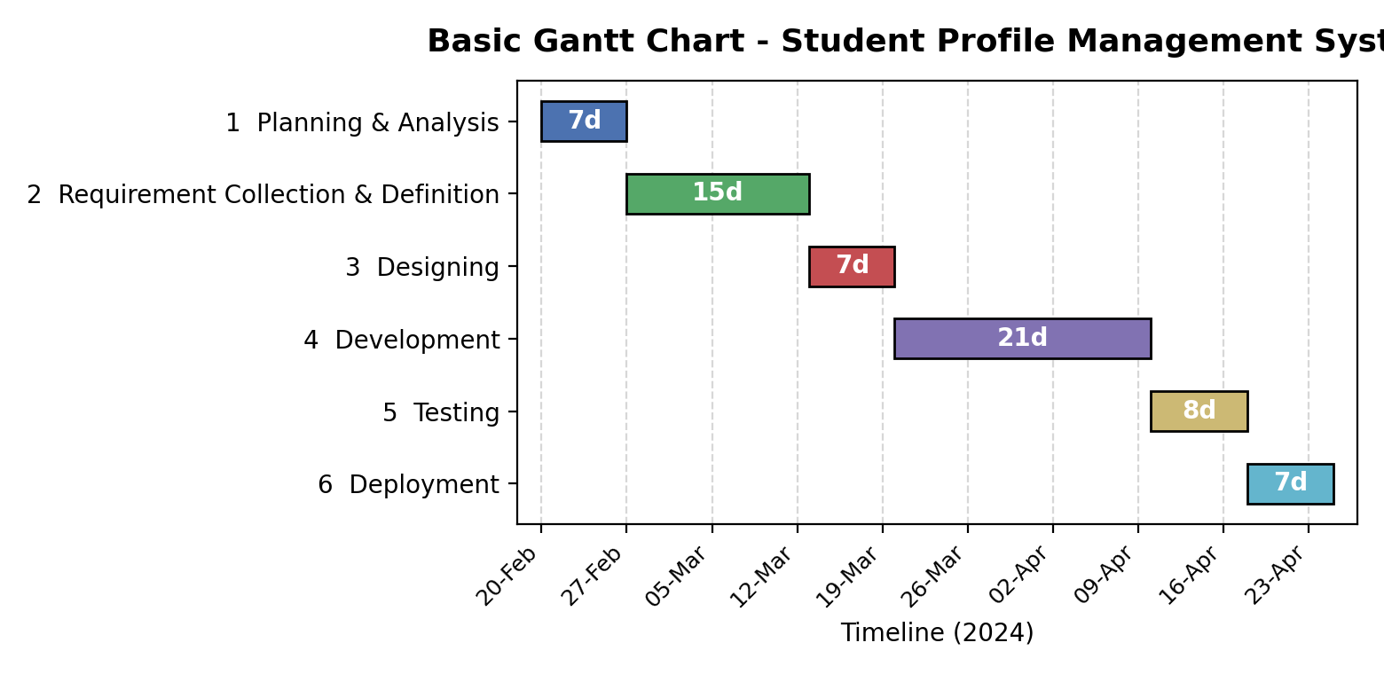
Fig 1: Basic Gantt Chart – Student Profile Management System

(ii) Relationship-based Gantt Chart (with dependency arrows)
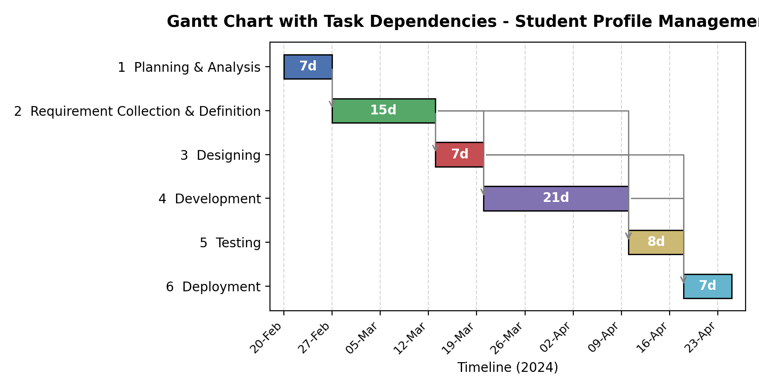
Fig 2: Relationship-based Gantt Chart showing Finish-to-Start dependency arrows

(d) Work Breakdown Structure (WBS) and Resource Breakdown Structure (RBS) Diagrams
Steps:
- In ProjectLibre, go to View → WBS Chart (or, if unavailable in the installed version, construct the WBS chart manually using the outline numbers assigned to each task, as shown below).
- The WBS decomposes the project into phases (Level 1) and further into deliverable-based work packages (Level 2).
- For the RBS, go to View → Resource Sheet to list all resources, then group them by category (Human Resources / Material Resources) to draw the RBS hierarchy.

Work Breakdown Structure (WBS)
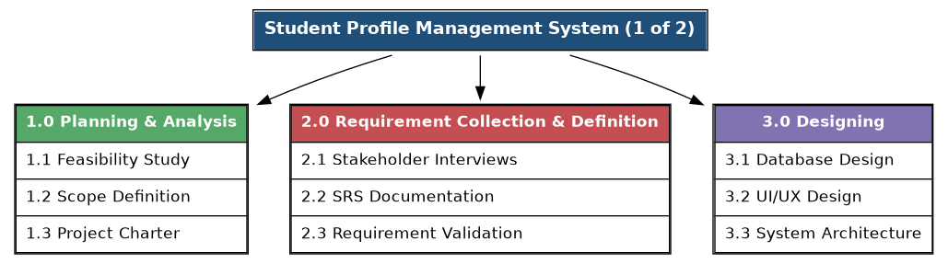
Fig 3a: WBS – Phases 1 to 3
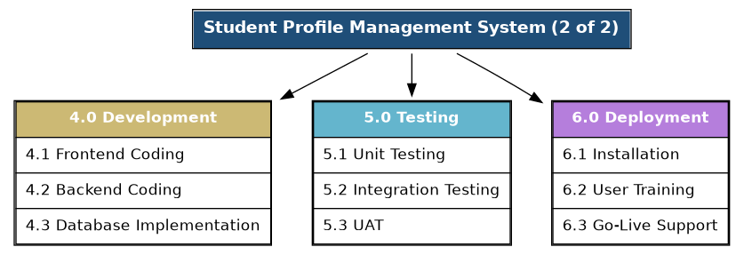
Fig 3b: WBS – Phases 4 to 6

Resource Breakdown Structure (RBS)
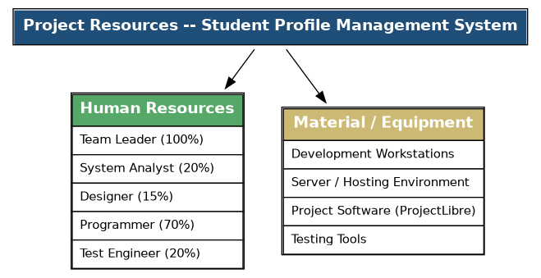
Fig 4: Resource Breakdown Structure (RBS) – Student Profile Management System

(e) Task Usage and Resource Usage Reports
Steps:
- Go to View → Task Usage to see each task with its assigned resource(s) and the time-phased work (hours).
- Go to View → Resource Usage to see each resource with the list of tasks it is assigned to and total work.
- Work is computed as: Work = Duration × Resource Units (e.g., Programmer at 70% for 21 days × 8 hrs/day = 117.6 hrs).

Task Usage Report
S.N | Task | Duration | Resource | Units | Work (hrs)
1 | Planning & Analysis | 7d | Team Leader | 100% | 56.0
2 | Requirement Collection & Definition | 15d | System Analyst | 20% | 24.0
3 | Designing | 7d | Designer | 15% | 8.4
4 | Development | 21d | Programmer | 70% | 117.6
5 | Testing | 8d | Test Engineer | 20% | 12.8
6 | Deployment | 7d | Not assigned | — | 0.0

Resource Usage Report
S.N | Resource | Assigned Task(s) | Units | Total Work (hrs)
1 | Team Leader | Planning & Analysis | 100% | 56.0
2 | System Analyst | Requirement Collection & Definition | 20% | 24.0
3 | Designer | Designing | 15% | 8.4
4 | Programmer | Development | 70% | 117.6
5 | Test Engineer | Testing | 20% | 12.8
[Insert Screenshot: ProjectLibre Task Usage view and Resource Usage view]

(f) Network Modeling Diagram — PERT Chart and CPM
Steps:
- Go to View → Network Diagram (PERT Chart) in ProjectLibre to view the Activity-on-Node (AON) network automatically generated from the task list and predecessors.
- Each node box shows the task ID, name, duration, and (once the CPM calculation is run via Tools → Options or the built-in scheduler) the Early Start (ES), Early Finish (EF), Late Start (LS) and Late Finish (LF).
- Critical tasks (zero slack/float) are usually highlighted in red by the tool.
- The Critical Path is the longest path through the network and determines the minimum project duration.
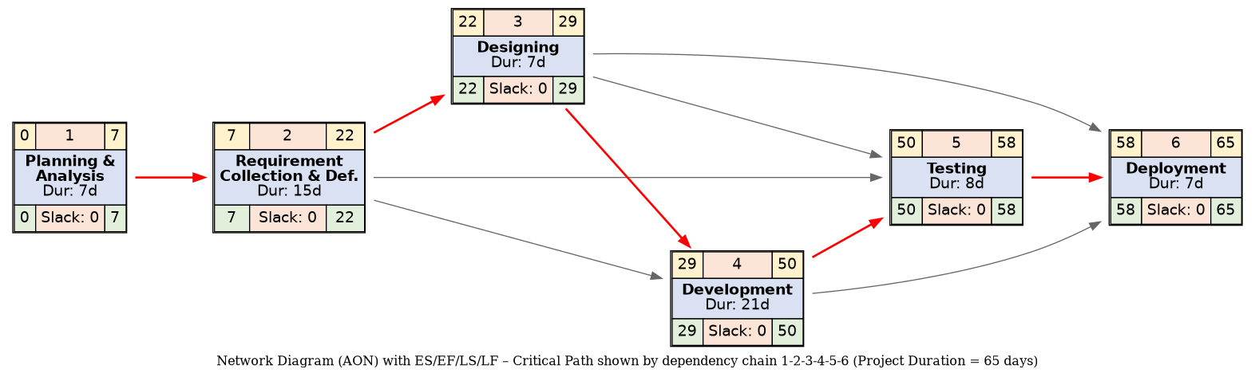
Fig 5: PERT/CPM Network Diagram (AON) — Student Profile Management System
Analysis: Since every activity in this project depends directly on the completion of all its predecessors in a single sequential chain (1→2→3→4→5→6), there is only one path through the network. Hence all six activities are critical, with zero slack, and the Critical Path is:
Critical Path: 1 → 2 → 3 → 4 → 5 → 6
Project Duration = 7 + 15 + 7 + 21 + 8 + 7 = 65 days

Task 2: PERT Diagram and Critical Path
Given the following project activities:
Activity | Predecessor | Duration
A | — | 2
B | A | 4
C | A | 5
D | B | 6
E | C | 3
F | D, E | 4

Forward Pass (Earliest Start / Earliest Finish)
- ES(A) = 0, EF(A) = 0 + 2 = 2
- ES(B) = EF(A) = 2, EF(B) = 2 + 4 = 6
- ES(C) = EF(A) = 2, EF(C) = 2 + 5 = 7
- ES(D) = EF(B) = 6, EF(D) = 6 + 6 = 12
- ES(E) = EF(C) = 7, EF(E) = 7 + 3 = 10
- ES(F) = max(EF(D), EF(E)) = max(12, 10) = 12, EF(F) = 12 + 4 = 16

Backward Pass (Latest Start / Latest Finish)
- LF(F) = 16, LS(F) = 16 − 4 = 12
- LF(D) = LS(F) = 12, LS(D) = 12 − 6 = 6
- LF(E) = LS(F) = 12, LS(E) = 12 − 3 = 9
- LF(B) = LS(D) = 6, LS(B) = 6 − 4 = 2
- LF(C) = LS(E) = 9, LS(C) = 9 − 5 = 4
- LF(A) = min(LS(B), LS(C)) = min(2, 4) = 2, LS(A) = 2 − 2 = 0

Slack / Float Table
Activity | ES | EF | LS | LF | Slack (LS−ES) | Critical?
A | 0 | 2 | 0 | 2 | 0 | Yes
B | 2 | 6 | 2 | 6 | 0 | Yes
C | 2 | 7 | 4 | 9 | 2 | No
D | 6 | 12 | 6 | 12 | 0 | Yes
E | 7 | 10 | 9 | 12 | 2 | No
F | 12 | 16 | 12 | 16 | 0 | Yes

PERT / CPM Network Diagram
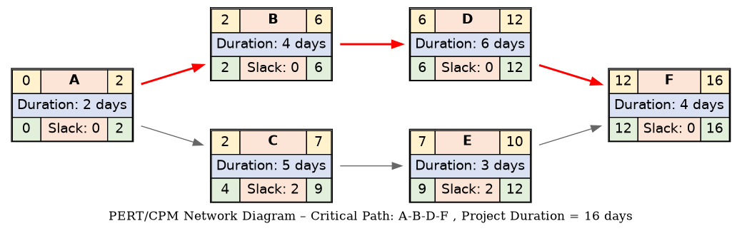
Fig 6: PERT Network Diagram – Activities A to F
Path comparison:
- Path A–B–D–F = 2 + 4 + 6 + 4 = 16 days
- Path A–C–E–F = 2 + 5 + 3 + 4 = 14 days
Critical Path: A → B → D → F
Project Duration = 16 days

Task 3: AOA Network Diagram and Critical Path Calculation
Given activities represented in (i, j) node notation:
Activity (i, j) | Duration (Days)
(1, 2) | 4
(1, 3) | 6
(2, 4) | 5
(3, 4) | 3
(4, 5) | 2
(3, 5) | 8

Forward Pass — Earliest Event Time E(j)
- E(1) = 0
- E(2) = E(1) + 4 = 0 + 4 = 4
- E(3) = E(1) + 6 = 0 + 6 = 6
- E(4) = max[E(2)+5, E(3)+3] = max[4+5, 6+3] = max[9, 9] = 9
- E(5) = max[E(4)+2, E(3)+8] = max[9+2, 6+8] = max[11, 14] = 14

Backward Pass — Latest Event Time L(i)
- L(5) = 14
- L(4) = L(5) − 2 = 14 − 2 = 12
- L(3) = min[L(4)−3, L(5)−8] = min[12−3, 14−8] = min[9, 6] = 6
- L(2) = L(4) − 5 = 12 − 5 = 7
- L(1) = min[L(2)−4, L(3)−6] = min[7−4, 6−6] = min[3, 0] = 0

Event Time Table
Event (Node) | Earliest Time E | Latest Time L | Slack (L−E) | Critical?
1 | 0 | 0 | 0 | Yes
2 | 4 | 7 | 3 | No
3 | 6 | 6 | 0 | Yes
4 | 9 | 12 | 3 | No
5 | 14 | 14 | 0 | Yes

AOA (Activity-on-Arrow) Network Diagram
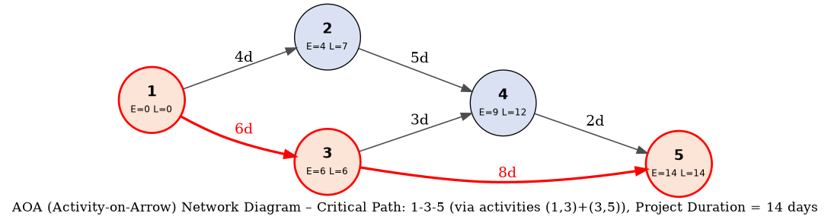
Fig 7: AOA Network Diagram — Nodes 1 to 5
An activity (i, j) lies on the critical path only if E(i)=L(i), E(j)=L(j), and E(i)+duration=E(j). Applying this test:
- (1,3): E(1)+6 = 0+6 = 6 = E(3) ✓ and both nodes critical → Critical
- (3,5): E(3)+8 = 6+8 = 14 = E(5) ✓ and both nodes critical → Critical
- (1,2), (2,4), (3,4), (4,5): fail the equality test → Not critical
Critical Path: 1 → 3 → 5 (via activities (1,3) and (3,5))
Project Duration = 6 + 8 = 14 days

Conclusion
This lab provided hands-on experience in software project scheduling using a project management tool (ProjectLibre) and manual network analysis. Key learnings include:
- Creating a project plan with a Work Breakdown Structure (WBS) linking tasks, durations, dates, dependencies and resources.
- Visualizing the schedule through basic and relationship (dependency-linked) Gantt charts.
- Decomposing the project into WBS and RBS hierarchies for clearer planning and resource allocation.
- Generating Task Usage and Resource Usage reports to track effort distribution.
- Applying the forward pass and backward pass technique of PERT/CPM to compute ES, EF, LS, LF, slack, and to identify the critical path — the sequence of activities with zero slack that determines the minimum project completion time.
For the three exercises: the Student Profile Management project has a critical path of 65 days along all six sequential activities; the six-activity PERT problem has a critical path A-B-D-F of 16 days; and the five-node AOA network has a critical path 1-3-5 of 14 days.

